Log In and Patient Registration
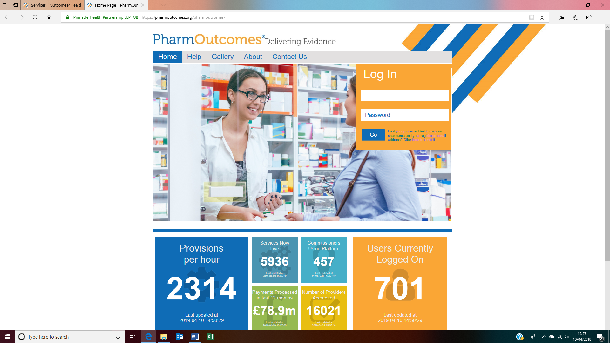
Log in to PharmOutcomes. Most pharmacies will already have access to PharmOutcomes, if not send a message to their helpdesk with pharmacy details and they will arrange an account.

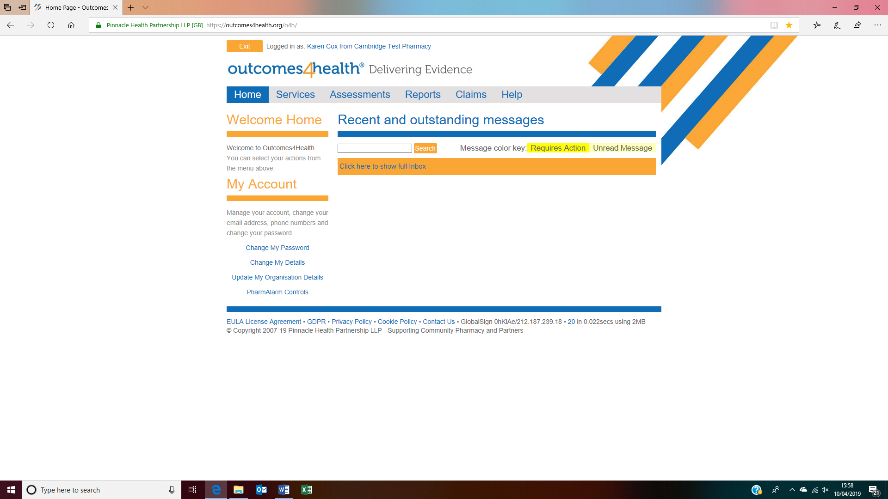
Click on the services tab.

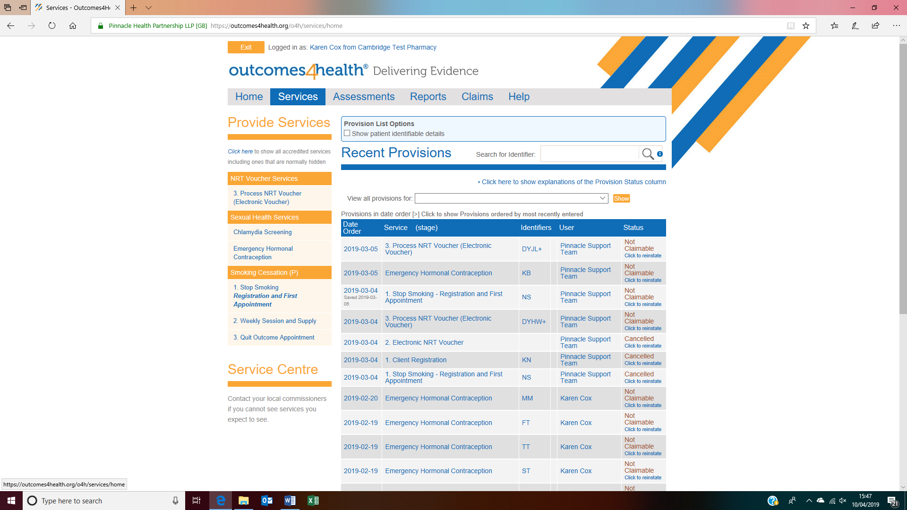
A list of all available services will be shown. Scroll down to find Smoking Cessation and click on Registration and First appointment. 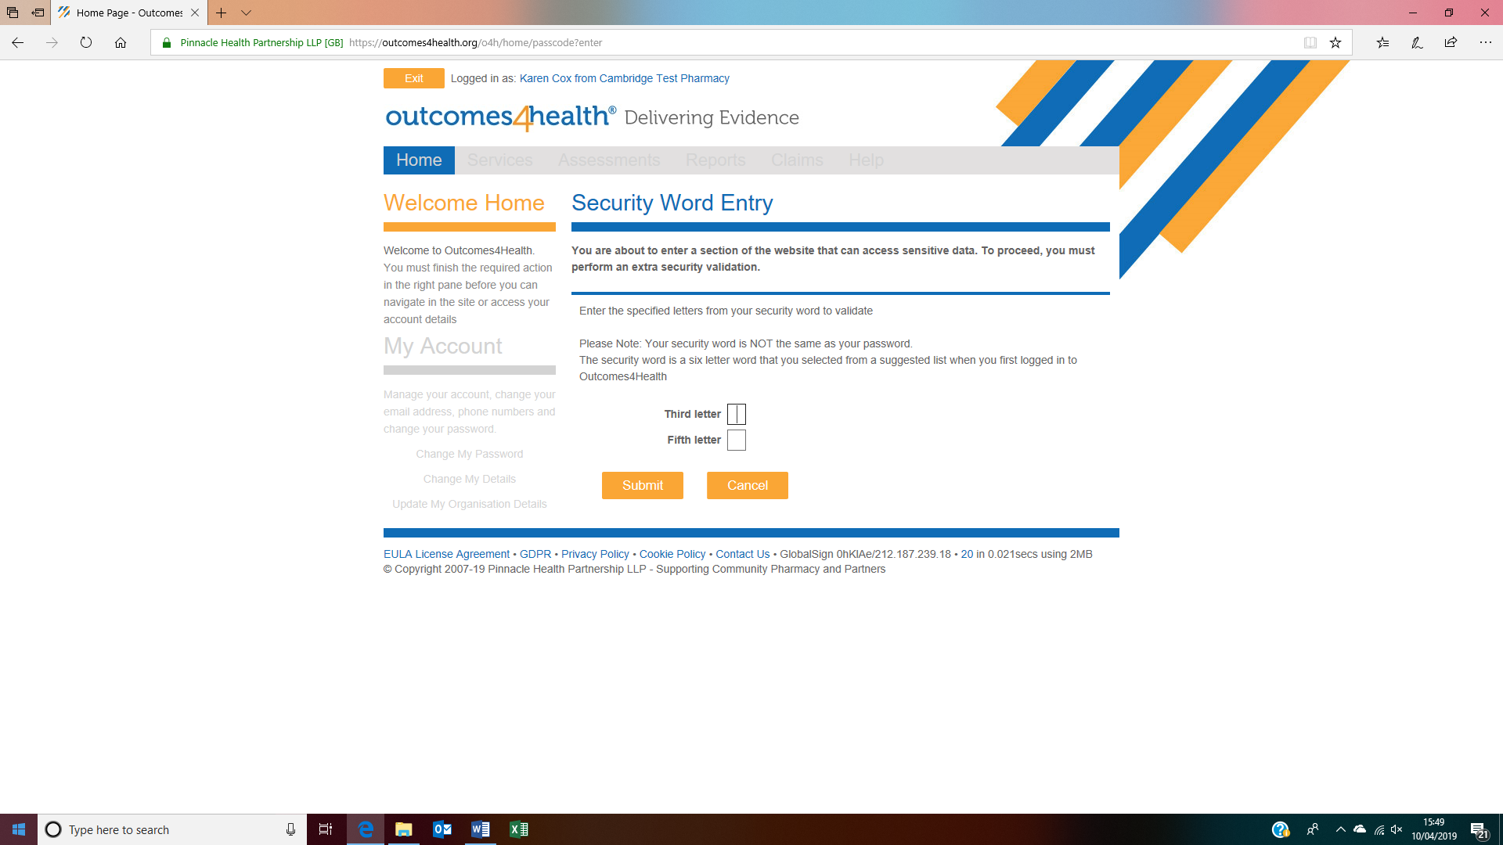
You will be asked to enter two letters from your security word (ask the person who gave you the log in details)

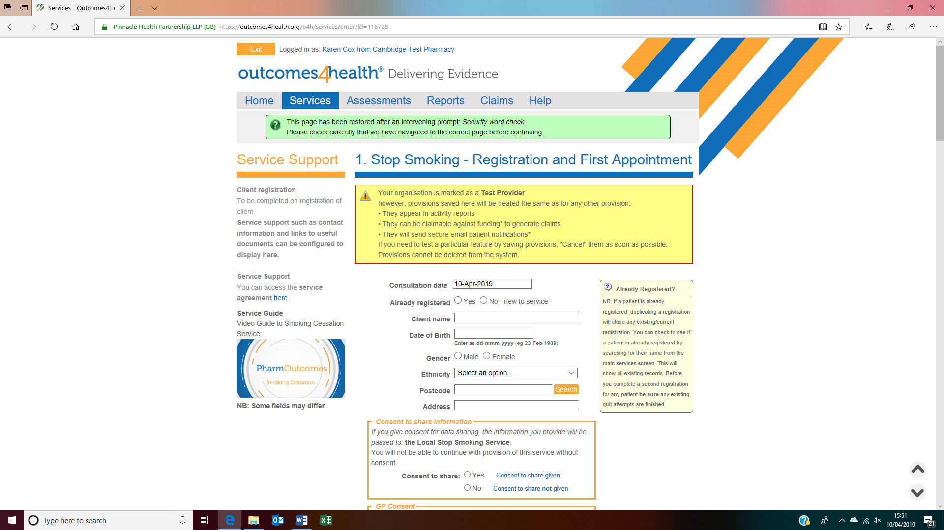
Fill in the patient details. Consent to share details with stop smoking service MUST be given to continue with the service.

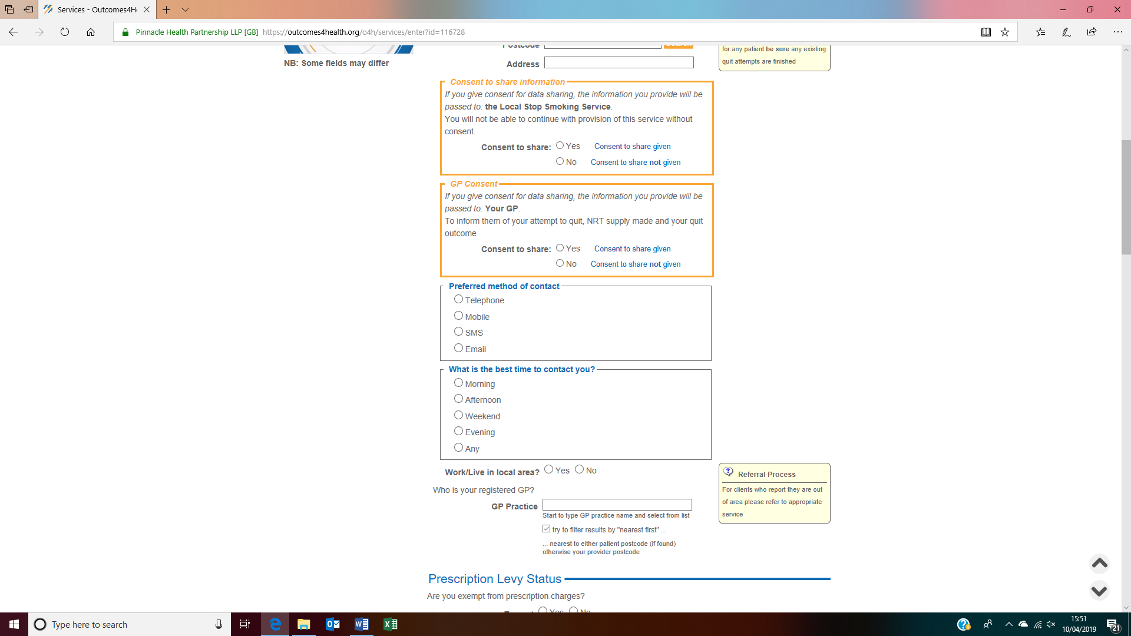
As above consent to share with GP MUST be given to continue with service. Fill in contact preferences, clicking an option will open a box underneath for the appropriate details. Enter GP Practice. Confirm that the patient lives or works in the local area.
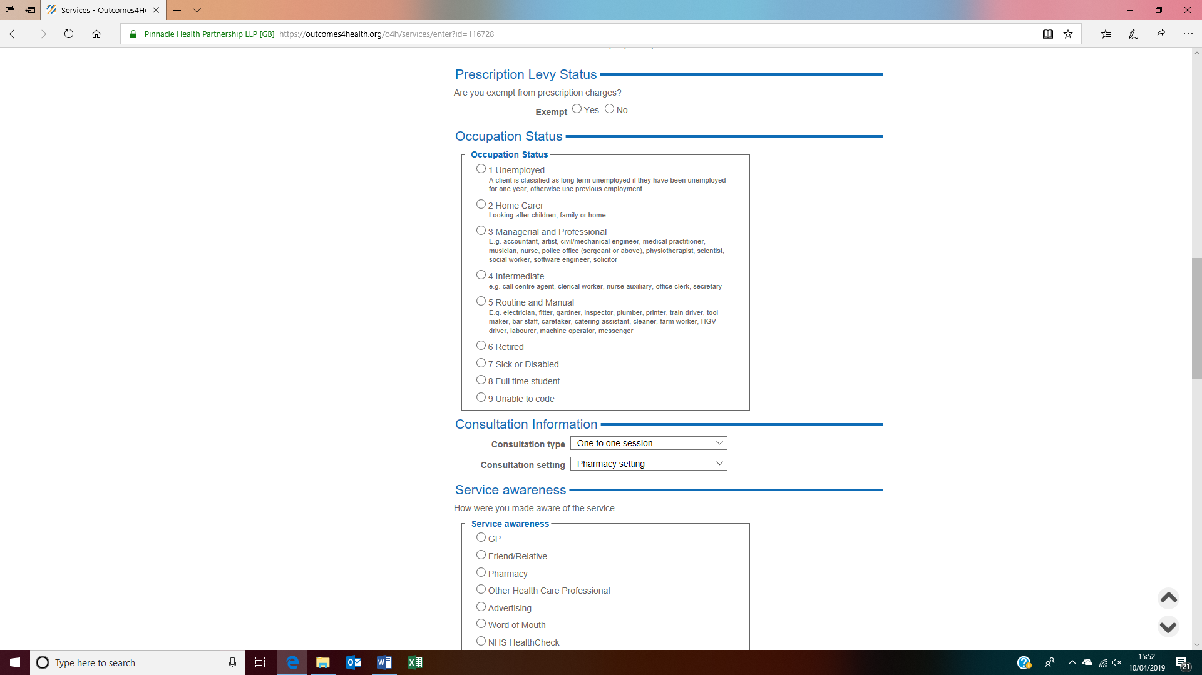
Enter patients exemption status, clicking exempt will open a box with the exemptions to chose from. Select occupation status and service awareness.
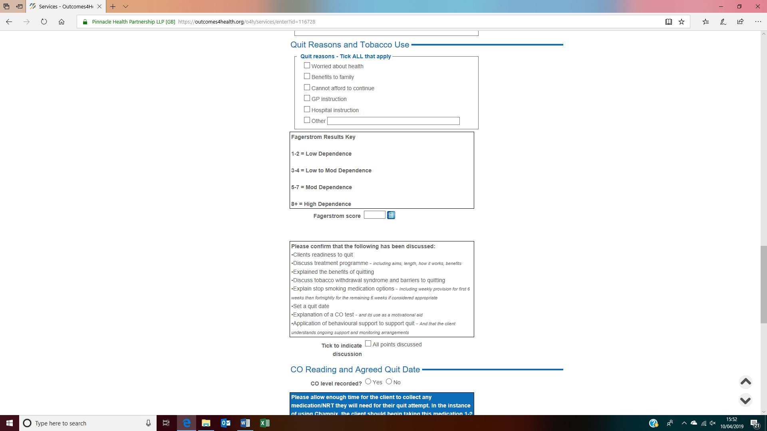
Select quit reasons. Clicking on the blue button will open a box with the Fagerstrom score questions and populating the answers will calculate the score for you.

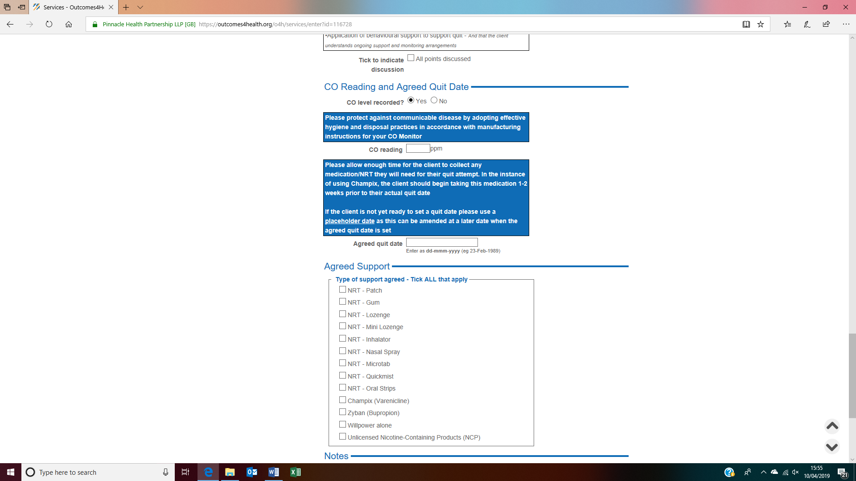
CO level recorded – clicking yes here will open a box to record score, clicking no will open a box for you to record why not. Enter agreed quit date, if client is undecided a ‘place holder’ date should be entered. This can be changed later by coming back in to the patients’ registration record.

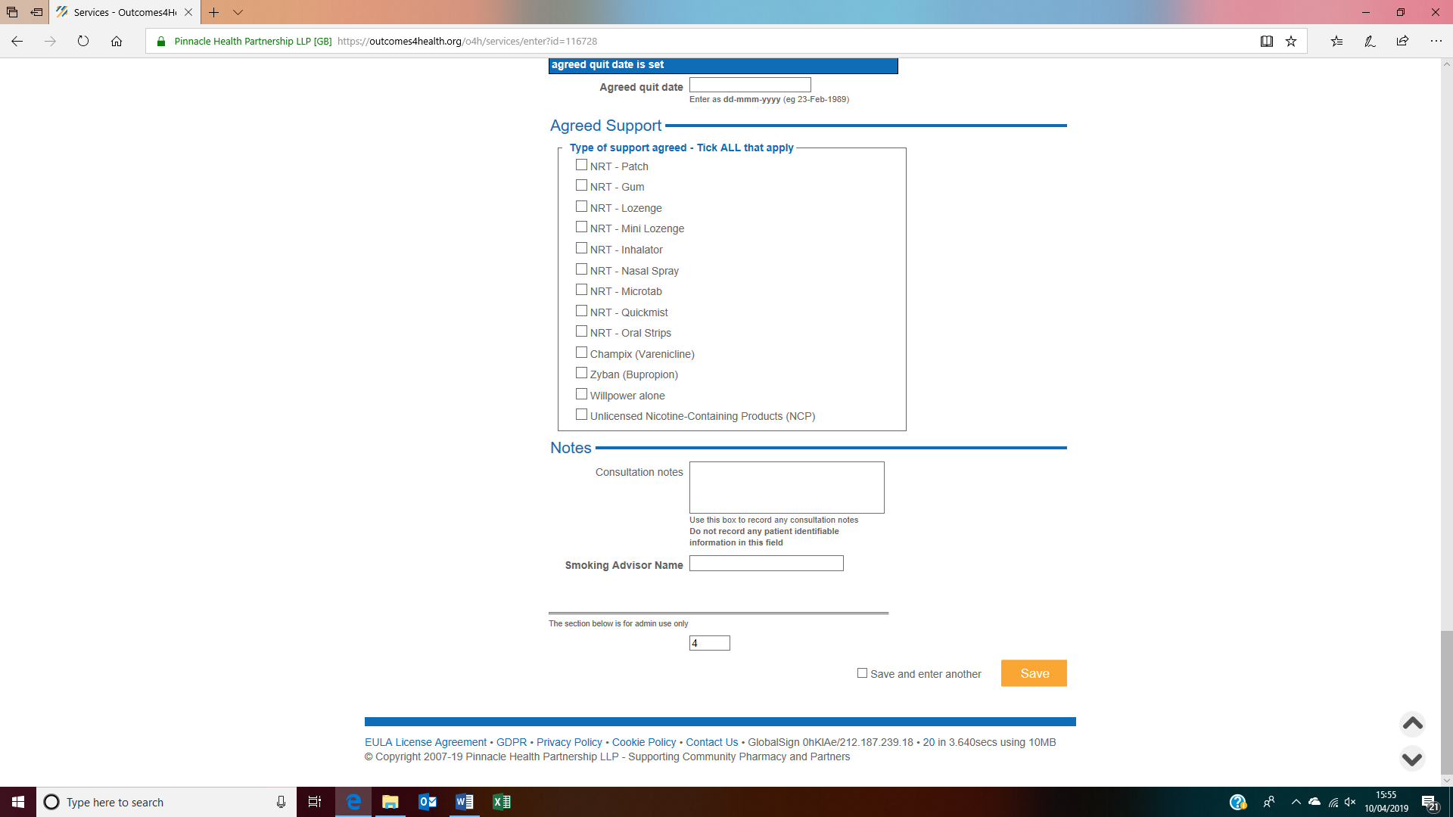
Select all agreed support types. Selecting Champix or Zyban will open a box to ask if a prescription is required. If yes is selected PharmOutcomes will automatically send a request to the patients GP when you save the session. If PharmOutcomes is unable to send an automatic request for any reason a message will appear on the top on the home screen so check here regularly. Enter any further notes (no identifiable data) and your name and then click save.

