East of England
Pharmacy Technician Leadership Group
Terms of Reference and Membership

Purpose
1.1 The NHS England (NHSE) East of England (EoE) Pharmacy Technicians Leadership Group (PTLG) is to provide support to experienced pharmacy technicians, focusing on areas such as professional development, workforce recruitment issues, national guidance and developments and any other issues relating to patient care and medicines optimisation.
1.2 It will provide a forum for NHS England to directly engage with pharmacy technicians in senior and leadership positions to seek opinion and build engagement, with the aim of becoming more inclusive of pharmacy technician expertise and opinion.
1.3 The group will act in an advisory capacity and will seek to utilise the professional views and opinions from the pharmacy technicians in the region to inform the NHSE Chief Pharmaceutical Officer’s Pharmacy Technician Professional Advisory Forum

Core Functions
1.4 To draw on professional expertise and experience to advise regional pharmacy boards and individual regional groups on significant issues affecting pharmacy technicians and support staff
1.5 To help create coherent professional views and opinions on matters affecting pharmacy technician professional development to the NHSE Chief Pharmaceutical Officer’s Pharmacy Technician Professional Advisory Forum
1.7 To maximise the regional impact and uptake of pharmacy initiatives or policy changes to effect real change through a co-ordinated and informed Pharmacy Technician leadership group.
1.8 To provide a strategic forum for pharmacy technicians in the East of England, where opportunities and challenges for the pharmacy technician profession can be shared, discussed and communicated with wider regional and national groups.
1.9 To support the sharing of learning to help support pharmacy technicians in their place of work in embedding good practice, delivering the medicines optimisation agenda and ensuring patient care
1.9 To support the pharmacy technicians in the region in identifying educational and training needs pertinent to their workplace setting
1.8 To broaden diversity and opinions to help inform an inclusive approach to pharmacy technician practice.
1.9 To embed equality, diversity, and inclusion principles including diversification of the forum to reflect the composition of characteristics in the pharmacy technician workforce in the region
2.0 To communicate the work of the Pharmacy Technician Leadership Group to internal and external stakeholders
2.1 To innovate and influence change, both within the region and on a national level
2.2 To support pharmacy technicians in their careers by providing opportunity to network and share best practice
2.3 To support professional empowerment of all pharmacy technicians as an integral part of the pharmacy team
2.4 The group will also support the delivery of the professional pharmacy aspects of the NHS Long Term Plan in the East of England

Membership
Chair
Pharmacy technician workforce lead – Deputy Chair
NHS England Representative – Deputy Chair
ICS pharmacy technicians ( max 2 per system)
HEE pharmacy technician representative
Pharmacy technician commissioning lead (if available)
PCN pharmacy technician lead
Mental Health pharmacy technician
Pharmacy technician workforce lead – Deputy Chair
NHS England Representative – Deputy Chair
Secondary care pharmacy technician lead
Community pharmacy technician
Ambulance service representative
Consideration will be given to other specialist and sectoral colleagues either on an ad-hoc basis as required or as members of the group.

Roles and Responsibilities
Each regional pharmacy technician group representative will have a responsibility to;
- Ensure that relevant information from the regional Pharmacy Technician leadership group is disseminated to colleagues within their ICS
- Ensure that the work of the Regional Pharmacy Technician leadership group effectively aligns with and supports the work of their ICS and that the ICS is informed and involved in the development of regional plans
- Work collaboratively to help resolve problems within programmes and Systems and provide leadership and direction where necessary
- Provide local leadership and co-ordination for transformation projects within their ICS such as Workforce development etc.
- Provide an accurate and transparent update to the group on progress, risks, and issues
- Nominate a deputy to attend the Regional Pharmacy Technician Leadership Group if unable to attend

Accountability
1.13 The NHS England Pharmacy Technician Leadership group will be chaired by Alishah Lakha and supported by Shingie Fundira and Michaela Aylward as the deputy chairs

Governance structure (To be confirmed)
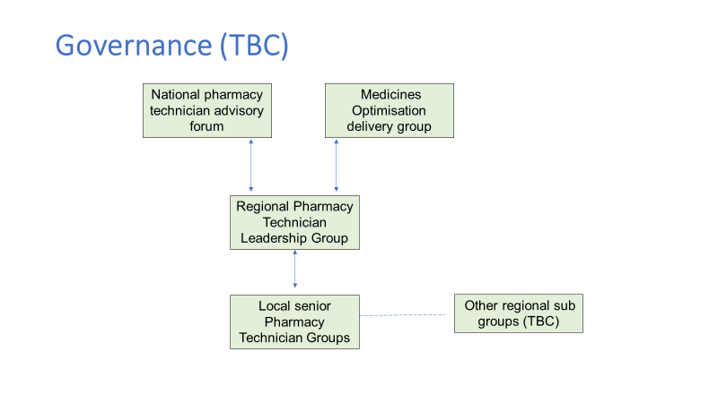

Quorum
1.15 A quorum is not required. Meetings will be set-up to ensure that as many of the membership can attend each meeting.

Meetings
1.16 Meetings will be quarterly virtual by MS Teams, lasting for a maximum of 2 hours.
Agenda will include the following areas
- Inclusive pharmacy practice
- Regional and national NHS England updates
- Updates from the Chief Pharmaceutical Office
- Education and workforce developments
- Shared learning

1.17 The chair is responsible for scheduling meetings, giving members as much notice as possible to facilitate maximal attendance and sending out agenda
1.18 The deputy chair(s) is responsible for supporting resources before the meeting and will provide secretariat.
1.19 Minutes shall be formally recorded for members and NHS England use, factual detail, and action points. Key headlines will be provided by the secretariat to support external communication cascade.
1.20 The secretariat is responsible for circulating the meeting minutes via email.
1.21 The chair may invite external advisors on an ad-hoc basis for the purpose of specialist advice. The chair will ensure that any external advisors are fully apprised of their role.
1.22 Meeting schedules will be agreed in advance with the membership and reflect the pace of work required.

Working Methods
1.21 Members are invited to express an interest in being part of the group, and will be selected according to their individual expertise and areas of practice.
1.22 Members are not representative of their employing organisations but may wish to share, disseminate, and reflect their organisations priorities to identify areas of commonality, avoiding duplication and supporting regional implementation where appropriate.
1.23 Any declarations of interest or items of discussion that may cause conflict are to be discussed and raised directly with the chair before or during the meeting.

Non-Attendance
1.24 If group members are not able to attend a meeting they should:
- Give the chair their apologies in advance of the meeting.
- Provide feedback about any actions or priorities via email prior to the meeting.
- Nominate a deputy to attend on their behalf

Tenure
1.26 The membership will be reviewed annually. This is to support ensuring the membership reflects the diversity of the pharmacy technicians in the region and to ensure a balance of continuity and opportunities for new members to join.
1.27 If a member no longer wants to be a member of the forum or their position changes, they should communicate with the chair to discuss stepping down

Review of Terms of Reference
1.28 The group will review the relevance and value of its work and the Terms of Reference after 12 months.

