
Cervical screening – communications toolkit

Article for your website or newsletter
The local NHS is offering outreach clinics and education sessions encouraging those who’ve never had a cervical screening test or have not had one for a long time. Outreach clinics will take place at various community locations and at different times of the day, such as evenings, helping to improve access to these vital screening appointments. Appointments are available across the north of the county, covering Peterborough, Fenland and Huntingdonshire.
To book a local appointment telephone 01733 666670 and select option 1. Lines are open Monday to Friday 9am to 5pm, or visit https://www.greaterpeterboroughgps.nhs.uk/book-a-cervical-screening-appointment/

Posters
We have a range of posters which you can download and print.

Video
We have a video which you can use. The video explains what to expect at your cervical screening

Social media content
Below are some social media posts you can use. You can download the images here.
Post text | Image | Alt text
Outreach clinics for cervical cancer screening are taking place across Peterborough, Fenland and Huntingdonshire. To find and book an appointment near you telephone 01733 666670 and select option 1. Lines are open Monday to Friday 9am to 5pm, or visit https://www.greaterpeterboroughgps.nhs.uk/book-a-cervical-screening-appointment/ | 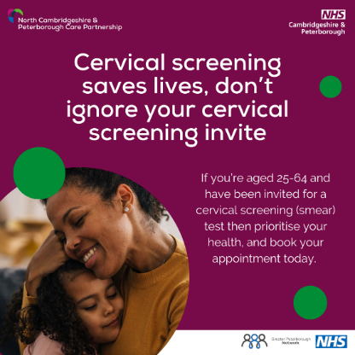 | Text: Cervical screening saves lives, don’t ignore your cervical screening invite. If you’re aged 25-64 and have been invited for a cervical screening (smear) test then prioritise your health, and book your appointment today.’
Cervical cancer is the second most common cancer amongst women under 35, but screening can help stop it before it starts. Protect yourself - attend your cervical screening. Cervical screening saves lives. | 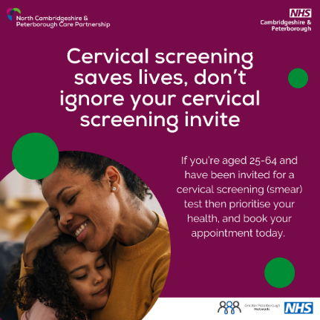 | Text: Cervical screening saves lives, don’t ignore your cervical screening invite. If you’re aged 25-64 and have been invited for a cervical screening (smear) test then prioritise your health, and book your appointment today.’
If you're overdue a cervical/smear test (maybe ignoring the letter you've been sent or missed an invite), then prioritise your health and get it booked in! |  | Text: Cervical screening saves lives, don’t ignore your cervical screening invite. If you’re aged 25-64 and have been invited for a cervical screening (smear) test then prioritise your health, and book your appointment today.’
If you are unsure when you last had a cervical/smear test or if you’re not sure whether you are overdue, call your GP practice to ask. | 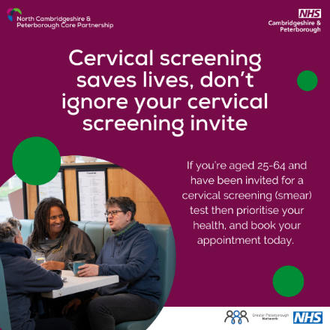 | Text: Cervical screening saves lives, don’t ignore your cervical screening invite. If you’re aged 25-64 and have been invited for a cervical screening (smear) test then prioritise your health, and book your appointment today.’
A cervical screening test takes less than five minutes. If you’ve been putting off your cervical/smear test then contact your GP practice and get it booked. |  | Text: Cervical screening saves lives, don’t ignore your cervical screening invite. If you’re aged 25-64 and have been invited for a cervical screening (smear) test then prioritise your health, and book your appointment today.  Additional appointments are available across Peterborough, Fenland and Huntingdonshire, including evening appointments.’

