PHARMACY OPENING TIMES
Christmas 2025-26
Christmas Day, Boxing Day & New Years’ Day
DATE | OPENING TIMES

You can find details of open local community pharmacies here:
https://www.nhs.uk/service-search/pharmacy/find-a-pharmacy
or scan the QR code to find an open local community pharmacy close to you:
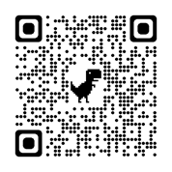
Alternatively, if you do not have access to the internet, please ask a relative or friend to check for you.
